South Metropolitan TAFE

Web Programming

Test documentation

PROJECT

Table of Contents

Test your code against the PEAR code standard with an appropriate static analysis tool 2

Original “Search.php” 2

After using PHP Beautify Tool 4

Original “display.php” 6

After using PHP Beautify Tool 8

Consistency Validation 10

Microsoft Edge 11

Google Chrome 12

Firefox 12

Software Risk Analysis Report 13

# Test your code against the PEAR code standard with an appropriate static analysis tool

## Original “Search.php”

<?php

$title = $_POST['title'];

if($_SERVER["REQUEST_METHOD"]=="POST"){

}

// Connect to database

$connection = mysqli_connect("localhost","root","","movies");

//Check Connection

if (!$connection){

die("Connection failed:" .mysqli_connect_error());

}

$title = $_POST['title'];

$rating = $_POST['rating'];

$genre = $_POST['genre'];

$year = $_POST['year'];

$sql = "SELECT * FROM movie_list WHERE title LIKE '%$title%' AND genre LIKE '%$genre%' AND rating LIKE '%$rating%' AND year LIKE '%$year%'";

$result = $connection->query($sql);

if ($result->num_rows > 0){

echo "<table class = 'centre' border=1>";

//Display header

echo "<tr>

<th>ID </th>

<th>Title </th>

<th>Studio </th>

<th>Status </th>

<th>Sound </th>

<th>Versions</th>

<th>Price </th>

<th>Rating </th>

<th>Year </th>

<th>Genre </th>

<th>Aspect </th>

</tr>";

while($row = mysqli_fetch_array($result)){

echo "<tr>";

echo "<td>" .$row['id'] ."</td>";

echo "<td>" .$row['title'] ."</td>";

echo "<td>" .$row['studio']. "</td>";

echo "<td>" .$row['status']. "</td>";

echo "<td>" .$row['sound']. "</td>";

echo "<td>" .$row['versions']. "</td>";

echo "<td>" .$row['price']. "</td>";

echo "<td>" .$row['rating']. "</td>";

echo "<td>" .$row['year']. "</td>";

echo "<td>" .$row['genre']. "</td>";

echo "<td>" .$row['aspect']. "</td>";

echo "</tr>";

}

}

else{

echo "No movie found";

}

mysqli_close($connection);

include "./templates/head.php";

?>

<?php

echo "<br><a href = 'Search.html'>Back</a></br>";

?>

## After using PHP Beautify Tool

<?php

$title = $_POST['title'];

if ($_SERVER["REQUEST_METHOD"] == "POST")

{

}

// Connect to database

$connection = mysqli_connect("localhost", "root", "", "movies");

//Check Connection

if (!$connection)

{

die("Connection failed:" . mysqli_connect_error());

}

$title = $_POST['title'];

$rating = $_POST['rating'];

$genre = $_POST['genre'];

$year = $_POST['year'];

$sql = "SELECT * FROM movie_list WHERE title LIKE '%$title%' AND genre LIKE '%$genre%' AND rating LIKE '%$rating%' AND year LIKE '%$year%'";

$result = $connection->query($sql);

if ($result->num_rows > 0)

{

echo "<table class = 'centre' border=1>";

//Display header

echo "<tr>

<th>ID </th>

<th>Title </th>

<th>Studio </th>

<th>Status </th>

<th>Sound </th>

<th>Versions</th>

<th>Price </th>

<th>Rating </th>

<th>Year </th>

<th>Genre </th>

<th>Aspect </th>

</tr>";

while ($row = mysqli_fetch_array($result))

{

echo "<tr>";

echo "<td>" . $row['id'] . "</td>";

echo "<td>" . $row['title'] . "</td>";

echo "<td>" . $row['studio'] . "</td>";

echo "<td>" . $row['status'] . "</td>";

echo "<td>" . $row['sound'] . "</td>";

echo "<td>" . $row['versions'] . "</td>";

echo "<td>" . $row['price'] . "</td>";

echo "<td>" . $row['rating'] . "</td>";

echo "<td>" . $row['year'] . "</td>";

echo "<td>" . $row['genre'] . "</td>";

echo "<td>" . $row['aspect'] . "</td>";

echo "</tr>";

}

}

else

{

echo "No movie found";

}

mysqli_close($connection);

include "./templates/head.php";

?>

<?php

echo "<br><a href = 'Search.html'>Back</a></br>";

?>

## Original “display.php”

<?php

if($_SERVER["REQUEST_METHOD"]=="POST"){

}

// Connect to database

$connection = mysqli_connect("localhost","root","","movies");

//Check Connection

if (!$connection){

die("Connection failed:" .mysqli_connect_error());

}

$sql = "SELECT * FROM movie_list";

$result = $connection->query($sql);

echo "<h2>Movies</h2>";

echo "<br><a href = 'index.html'>Back</a></br>";

if ($result->num_rows > 0){

echo "<table class = 'centre' border=1>";

//Display header

echo "<tr>

<th>ID </th>

<th>Title </th>

<th>Studio </th>

<th>Status </th>

<th>Sound </th>

<th>Versions</th>

<th>Price </th>

<th>Rating </th>

<th>Year </th>

<th>Genre </th>

<th>Aspect </th>

</tr>";

while($row = mysqli_fetch_array($result)){

echo "<tr>";

echo "<td>" .$row['id'] ."</td>";

echo "<td>" .$row['title'] ."</td>";

echo "<td>" .$row['studio']. "</td>";

echo "<td>" .$row['status']. "</td>";

echo "<td>" .$row['sound']. "</td>";

echo "<td>" .$row['versions']. "</td>";

echo "<td>" .$row['price']. "</td>";

echo "<td>" .$row['rating']. "</td>";

echo "<td>" .$row['year']. "</td>";

echo "<td>" .$row['genre']. "</td>";

echo "<td>" .$row['aspect']. "</td>";

echo "</tr>";

}

}

mysqli_close($connection);

include "./templates/head.php";

?>

## After using PHP Beautify Tool

<?php

if ($_SERVER["REQUEST_METHOD"] == "POST")

{

}

// Connect to database

$connection = mysqli_connect("localhost", "root", "", "movies");

//Check Connection

if (!$connection)

{

die("Connection failed:" . mysqli_connect_error());

}

$sql = "SELECT * FROM movie_list";

$result = $connection->query($sql);

echo "<h2>Movies</h2>";

echo "<br><a href = 'index.html'>Back</a></br>";

if ($result->num_rows > 0)

{

echo "<table class = 'centre' border=1>";

//Display header

echo "<tr>

<th>ID </th>

<th>Title </th>

<th>Studio </th>

<th>Status </th>

<th>Sound </th>

<th>Versions</th>

<th>Price </th>

<th>Rating </th>

<th>Year </th>

<th>Genre </th>

<th>Aspect </th>

</tr>";

while ($row = mysqli_fetch_array($result))

{

echo "<tr>";

echo "<td>" . $row['id'] . "</td>";

echo "<td>" . $row['title'] . "</td>";

echo "<td>" . $row['studio'] . "</td>";

echo "<td>" . $row['status'] . "</td>";

echo "<td>" . $row['sound'] . "</td>";

echo "<td>" . $row['versions'] . "</td>";

echo "<td>" . $row['price'] . "</td>";

echo "<td>" . $row['rating'] . "</td>";

echo "<td>" . $row['year'] . "</td>";

echo "<td>" . $row['genre'] . "</td>";

echo "<td>" . $row['aspect'] . "</td>";

echo "</tr>";

}

}

mysqli_close($connection);

include "./templates/head.php";

?>

# Consistency Validation

## Microsoft Edge

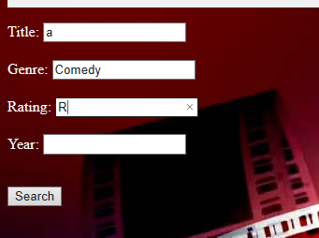

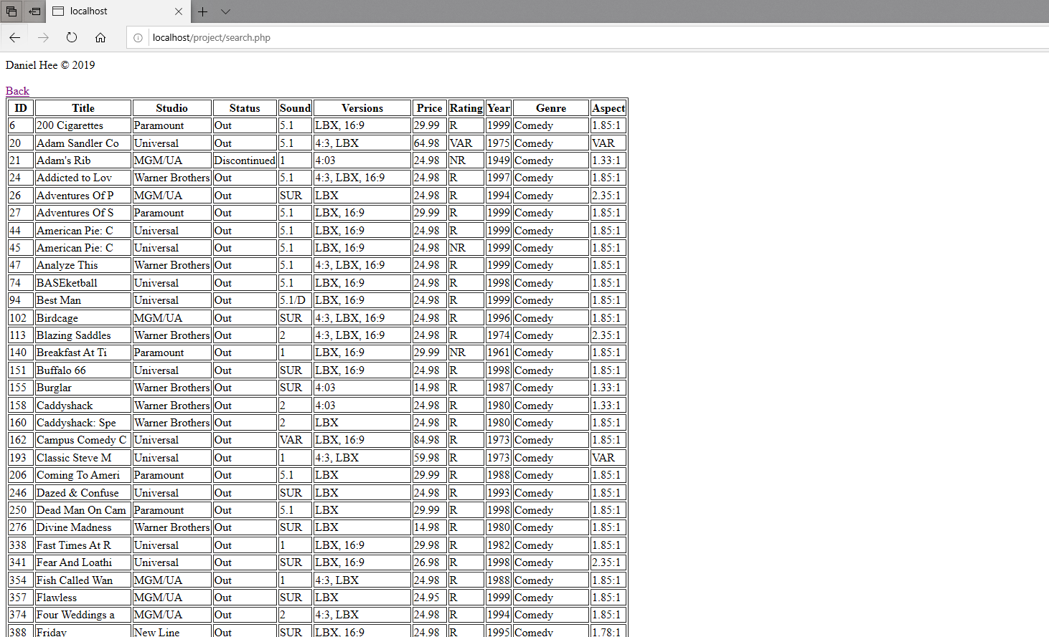

Result is searched and displayed based on the input data provided.

## Google Chrome

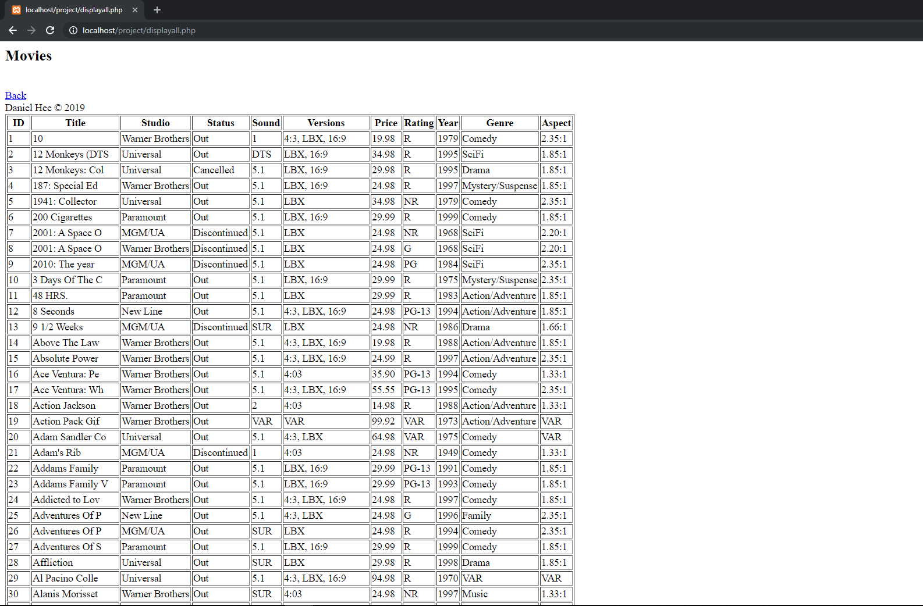

Display all movies information once button is clicked.

## Firefox

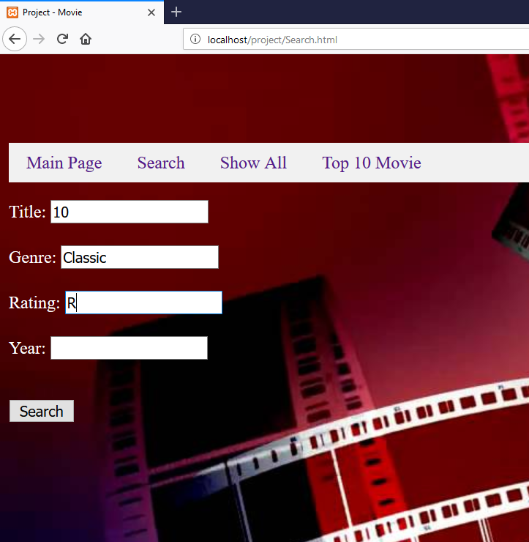

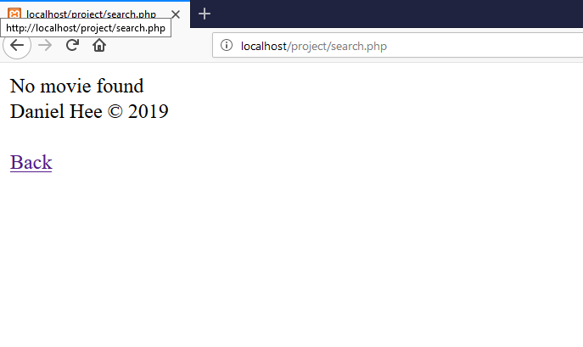

Result is searched and displayed based on the input data provided. If result is not found, it will display No Movie Found.



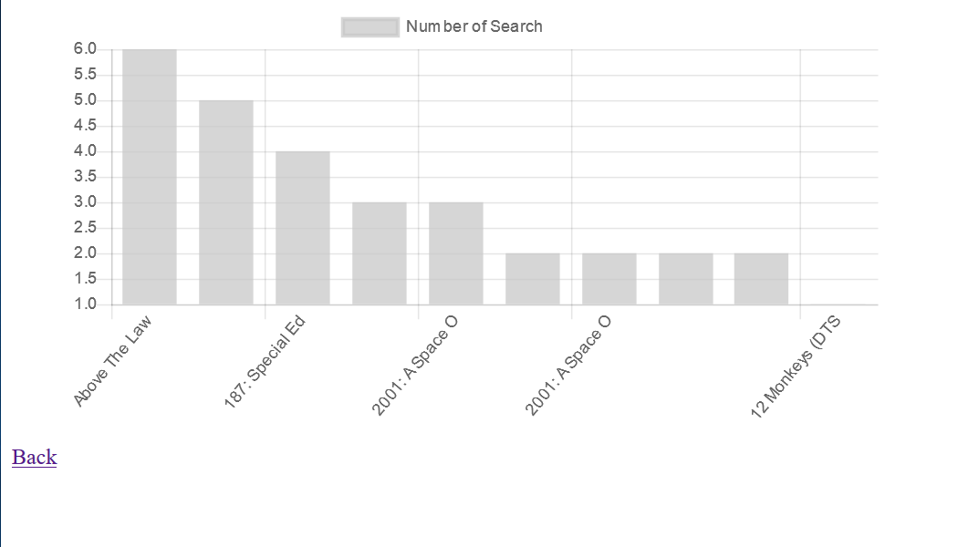

Graph is generated when the button is pressed.

# Software Risk Analysis Report

If there is an error in my code when I am running it. The internet browsers will provide all Parse Error with proper comment and on which line.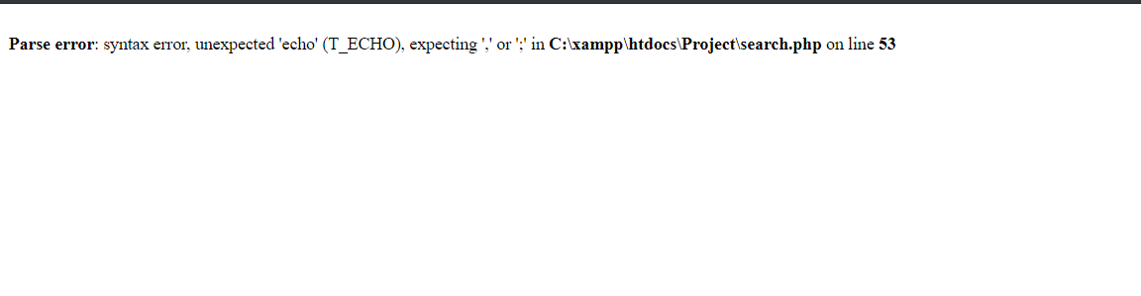

Based on the comment provided, I will be able to make amendment towards my code in order for it to run smoothly.